**Linear Regression Questions ( Make Sure to watch the videos 1st )**

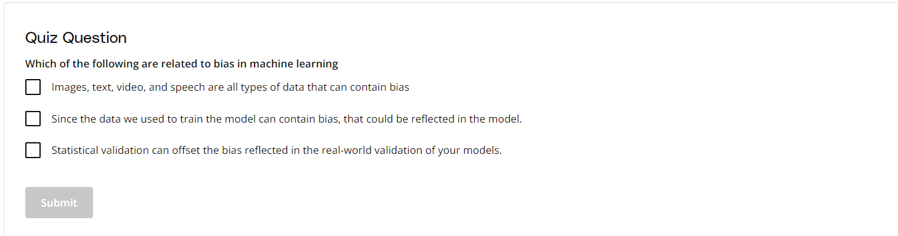

Write A, B, or C here (you can choose more than one answer if there is): A,B

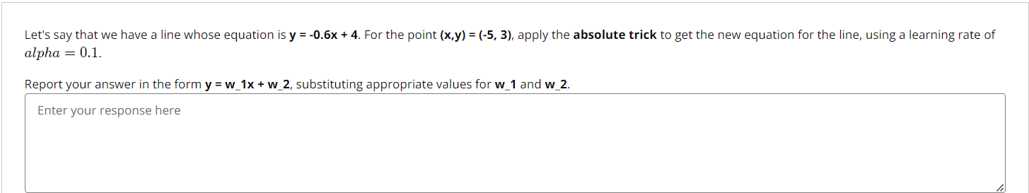

Enter your response here: The given equation of the line is:

y = -0.6x + 4

or equivalently:

y = w₁x + w₂,

where w₁ = -0.6 and w₂ = 4.

The given point is (x, y) = (-5, 3), and the learning rate α = 0.1.

Applying the Absolute Trick:

The absolute trick updates the weights using the rule:

w₁' = w₁ + α × sign(y - ŷ) × x

w₂' = w₂ + α × sign(y - ŷ)

where:

ŷ is the predicted value using the old equation:

ŷ = -0.6(-5) + 4 = 3 + 4 = 7

The error sign is:

sign(y - ŷ) = sign(3 - 7) = sign(-4) = -1

Updating w₁ and w₂:

w₁' = -0.6 + (0.1 × -1 × -5) = -0.6 + 0.5 = -0.1

w₂' = 4 + (0.1 × -1) = 4 - 0.1 = 3.9

Final Equation:

y = -0.1x + 3.9

So, the updated values are:

w₁ = -0.1, w₂ = 3.9

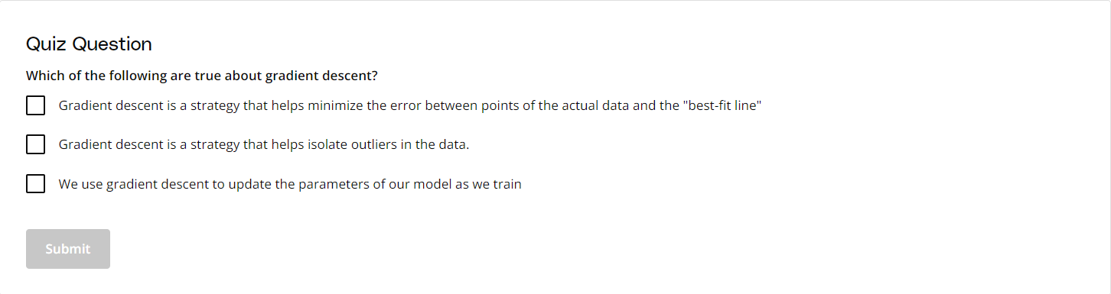

Write A, B, or C here (you can choose more than one answer if there is): A,C

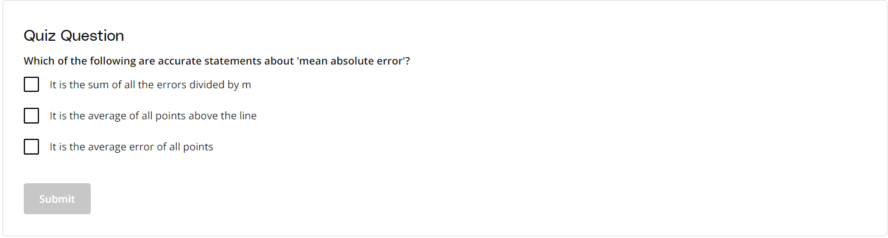

Write A, B, or C here (you can choose more than one answer if there is): A,C

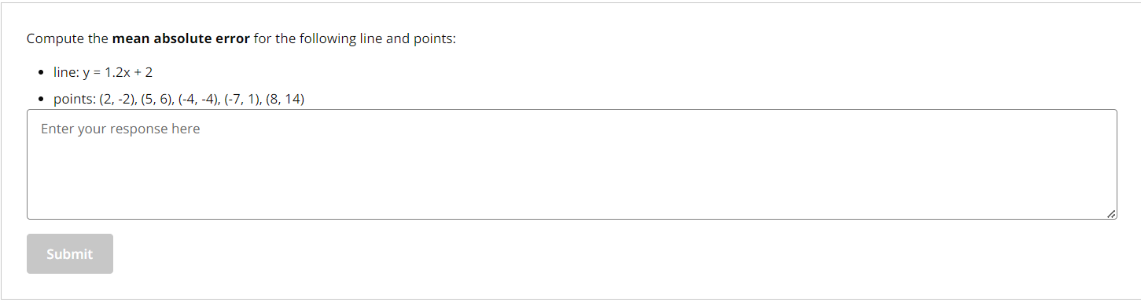

Enter your response here:

Mean Absolute Error :

(6.4 + 2 + 1.2 + 7.4 + 2.4) / 5 = 3.88

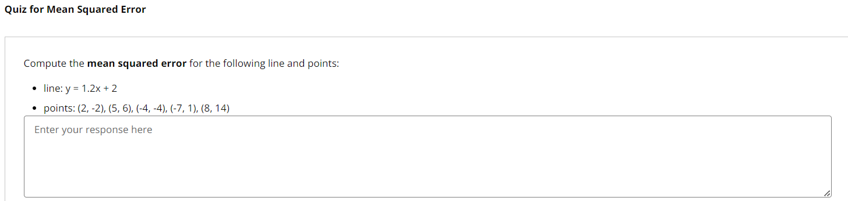

Enter your response here:   
Mean Squared Error :

(41.16 + 4 + 1.44 + 54.76 + 5.76) / 5 = 21.42

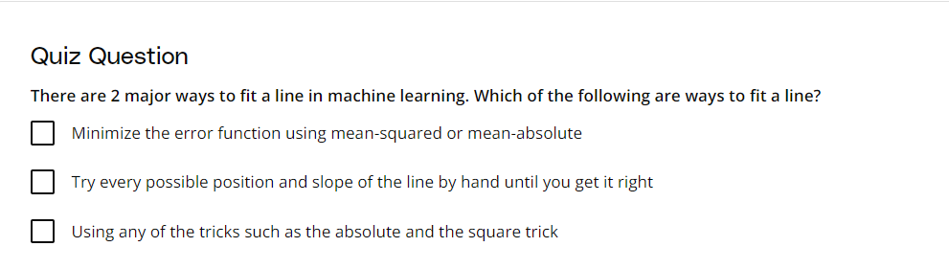

Write A, B, or C here (you can choose more than one answer if there is): A,C

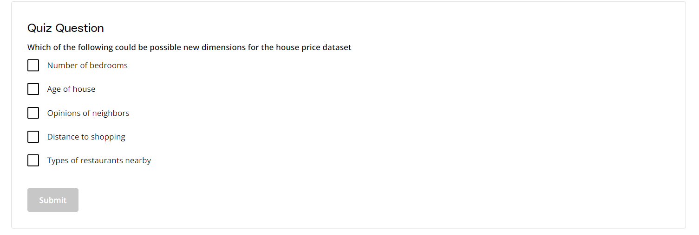

Write A, B, C, D, or E here (you can choose more than one answer if there is): A,D,E